How to Submit a Study in eIRB (Click)

Method 1 – Approve from e-mail (Study Staff uses “Notify PI of Submission” activity in eIRB):

- PI opens e-mail with subject Notify PI of Submission Ready for Review Activity from no-reply@eirb.providence.org AND clicks on link to study in body of e-mail. (See Figure 1)

- PI logs in to eIRB: (See Figure 2)
  - If you have a PSJH e-mail, use the Caregiver Logins button to log in from the PSJH network using your PSJH credentials.
  - If you do not have a PSJH e-mail, log in under External Partners.
    - Your e-mail address (the address the submission e-mail was sent to) is your User Name.
    - If it is your first time logging in, use the Forgot password? link to obtain your password.

- In the study workspace, PI reviews study application by clicking the Printer Version button and clicks the Close button to return to the study workspace.

- In the study workspace, PI clicks the Submit button, and clicks OK on the pop-up Submit screen. (See Figure 4)

Method 2 – Approve from PI Dashboard in eIRB:

- PI logs in to eIRB at: https://eirb.providence.org/ (See Figure 2)
  - If you have a PSJH e-mail, use the Caregiver Logins button to log in from the PSJH network using your PSJH credentials.
  - If you do not have a PSJH e-mail, log in under External Partners.
    - Your e-mail address is your User Name.
    - If it is your first time logging in, use the Forgot password? link to obtain your password.

- PI clicks on Dashboard, and the Name of study to be submitted under My Inbox. (See Figure 3)

- In the study workspace, PI reviews study application by clicking the Printer Version button and clicks the Close button to return to the study workspace.

- In the study workspace, PI clicks the Submit button, and clicks OK on the pop-up Submit screen. (See Figure 4)

If you encounter any issues logging in, are unsure about your username, or need other assistance, please contact IRBSharedServices@providence.org.

Figure 1 - Notify PI of Submission Ready for Review Activity e-mail
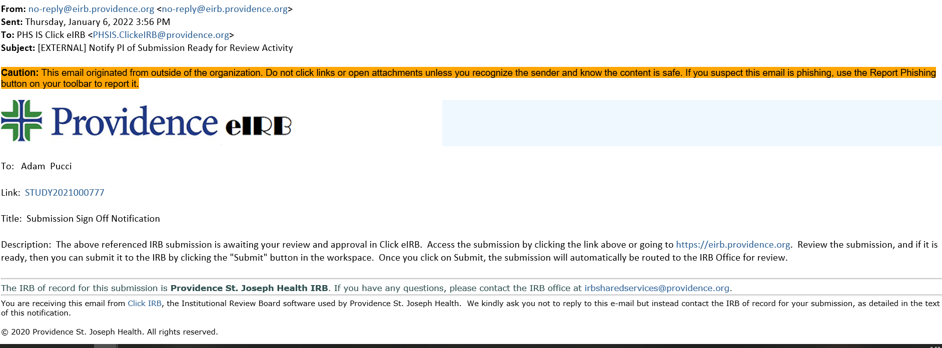
Click Link to Study

Figure 2 – Login Screen
If you have a PSJH e-mail, use Caregiver Logins to log in from the PSJH network using your PSJH credentials.

If you do not have a PSJH e-mail, log in under External Partners.

Figure 3 – Dashboard
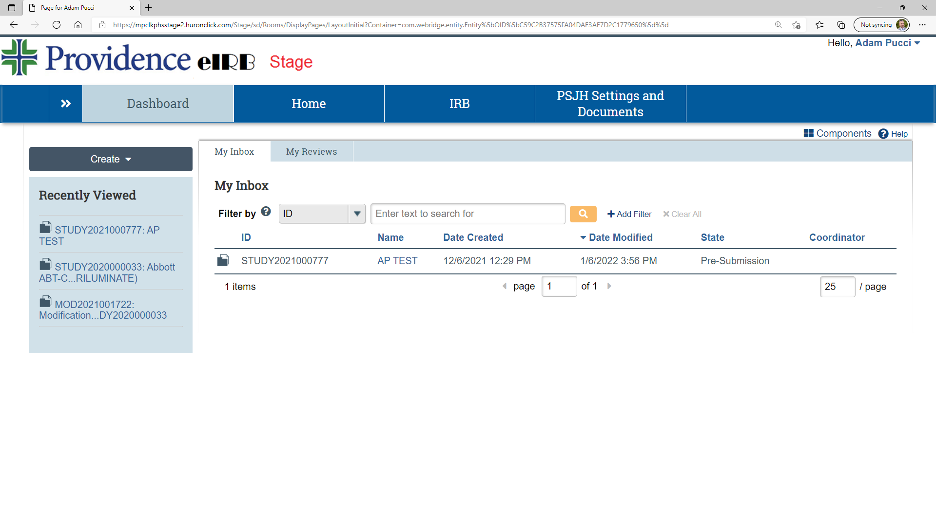
Click Dashboard, and the Name of study to be submitted.

Figure 4 – Study Workspace/Submit
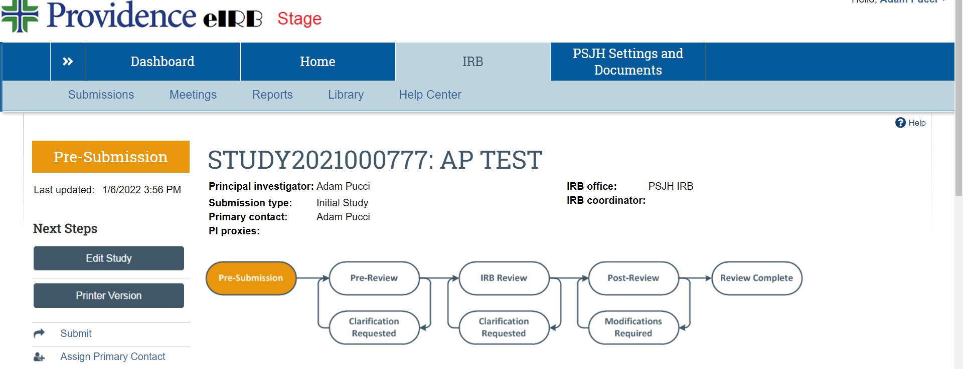
Click Submit.

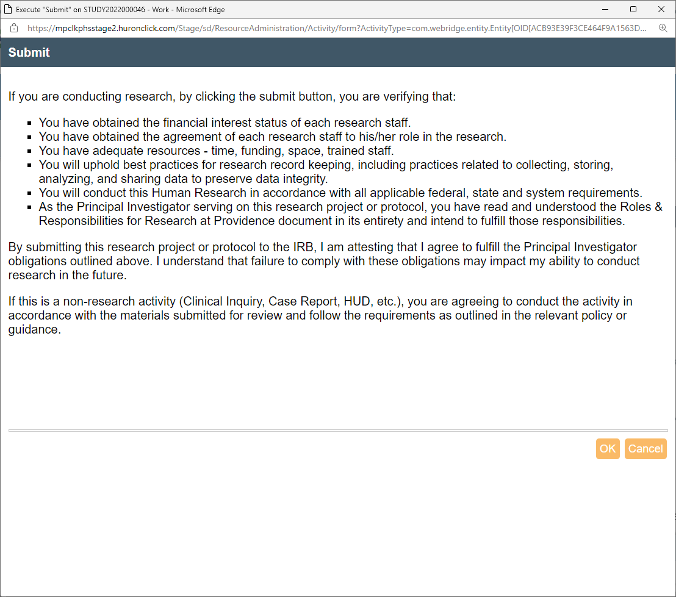
Click OK.

